Shanghai Ocean University Zero Trust VPN User Access Guide

Preparation (Very Important)
Add your security phone number in your personal profile in the Online Service Hall. Skip this step if it has already been set.

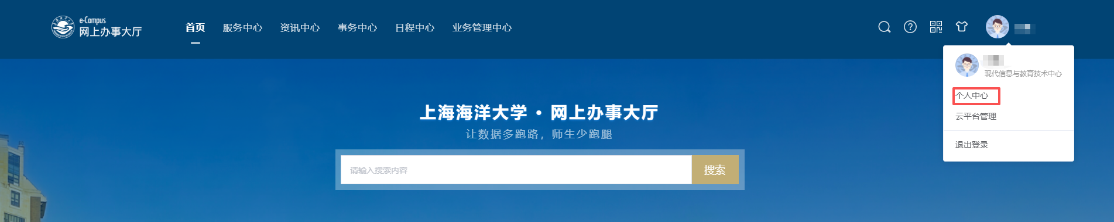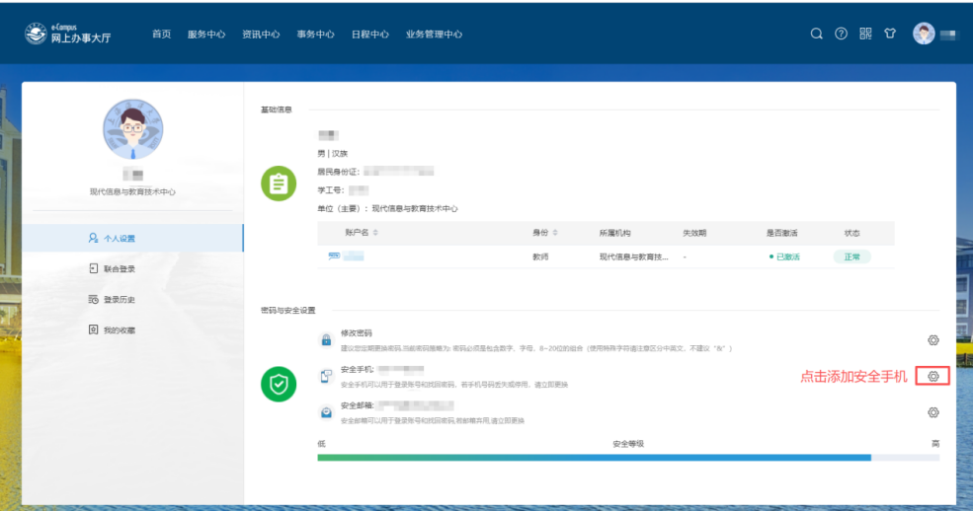

I. Accessing the Zero Trust VPN on a PC

Client Download
(1) Enter the Zero Trust VPN access address https://vpn4.shou.edu.cn in your browser to open the “Download Client” page, then click [Download Now]. (After the trial run ends, the access address will change to https://vpn.shou.edu.cn)

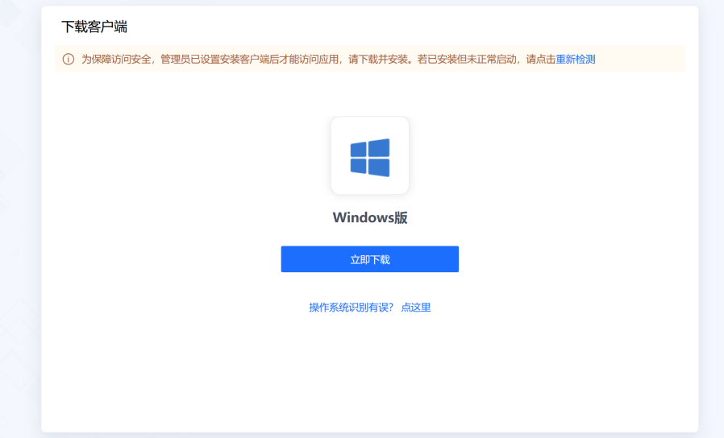

(2) If the computer operating system is misidentified, click the link “Operating system misidentified? Click here” at the bottom of the page and manually select the corresponding client version.

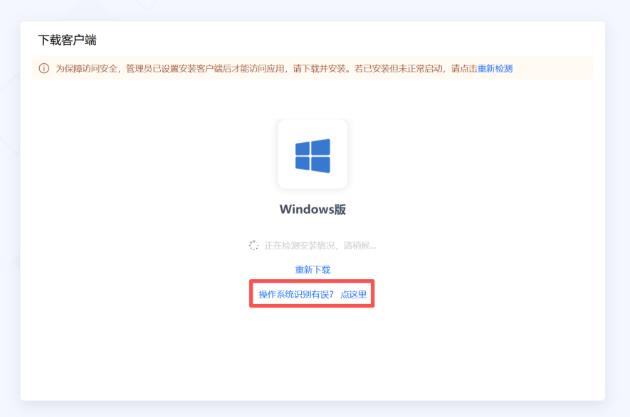

(3) You can also open the “More Client Downloads” page and choose the client according to your device type. The platform also supports iOS, Android, HarmonyOS, macOS, Windows, Linux and other versions.

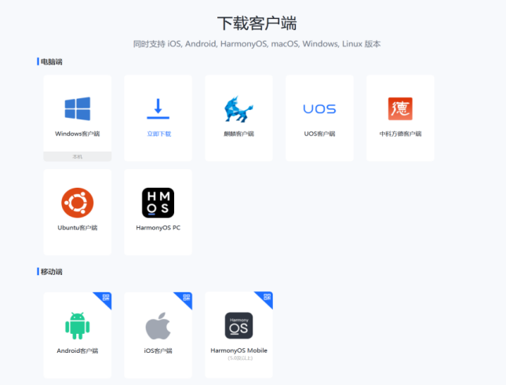

(4) Wait for the download to finish. The downloaded file is the aTrustInstaller installation package (exe format).

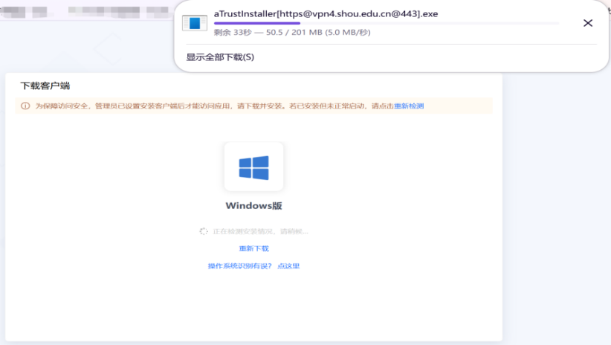

Client Installation
(1) Locate the downloaded installation package, double-click to run it, check “I have read and agree to the User Agreement”, then click [Install Now] and wait for the installation to complete.

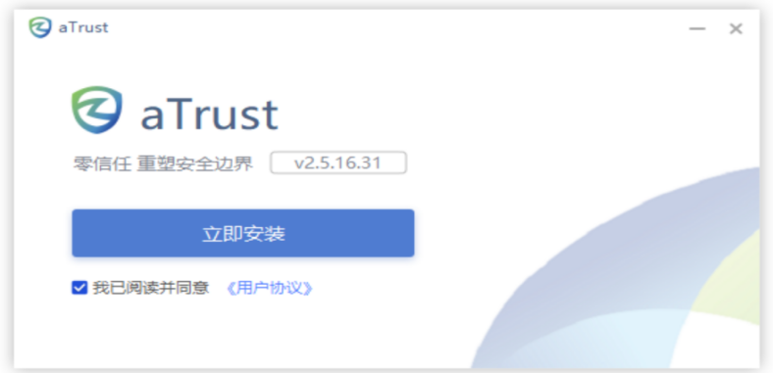

VPN Access
(1) After installation, the aTrust client login window opens automatically. Check “I have read and agree to the User Agreement” and click [Log In via Browser].

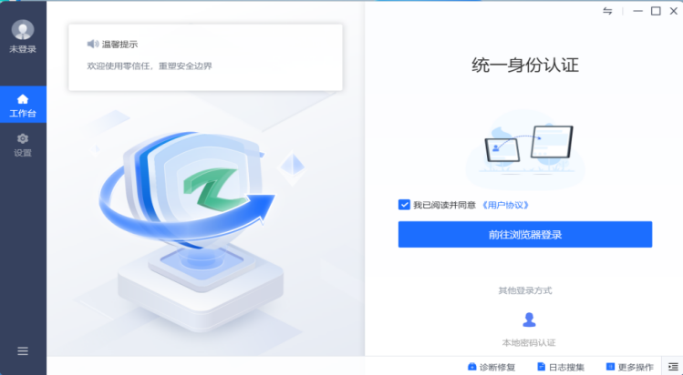

(2) You will then be redirected to the unified identity authentication login page. Verify with your Online Service Hall username and password, or choose “Mobile dynamic code login” or WeChat QR code login.

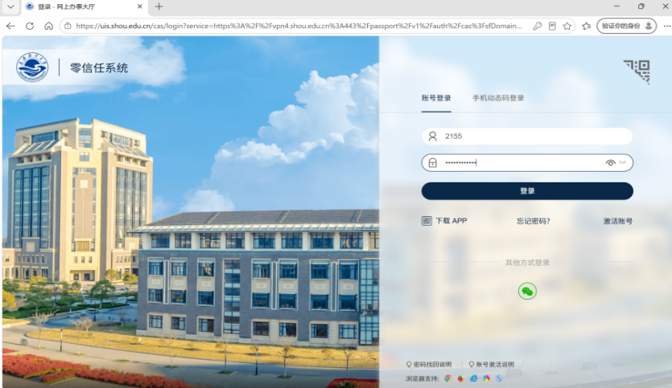

TOT Dynamic Token Binding (required at first login)
(1) At first login, the system detects that the account has not bound a dynamic token and prompts “It is detected that you have not bound a dynamic token. Please bind one before authentication”. Click [Start Binding]; without binding, the mobile VPN cannot be used.

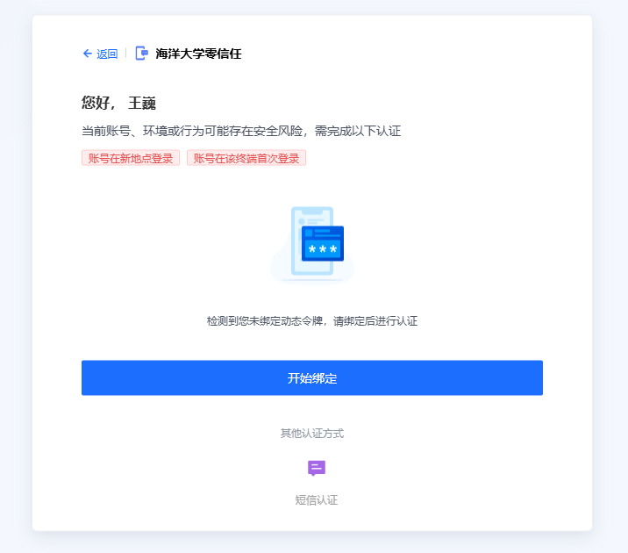

(2) Enter the “Token Authentication” page and bind a token for login authentication. The WeChat mini program “Tencent Authenticator” is recommended (see the next step); you may also install an authenticator app such as Microsoft Authenticator or Google Authenticator. Choose [Add by Scanning QR Code] and scan the QR code on the page with your phone to complete the binding.

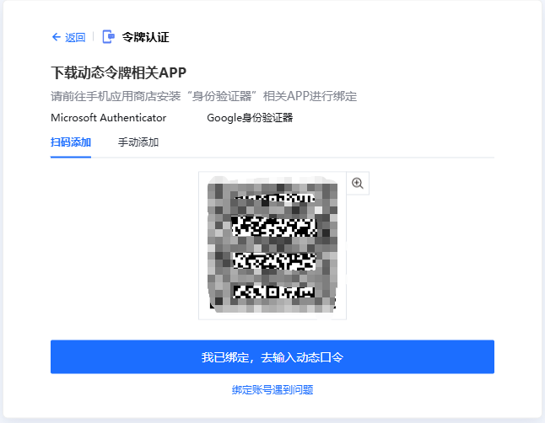

(3) Binding via WeChat mini program: search for the “Tencent Authenticator” mini program in WeChat and open it.

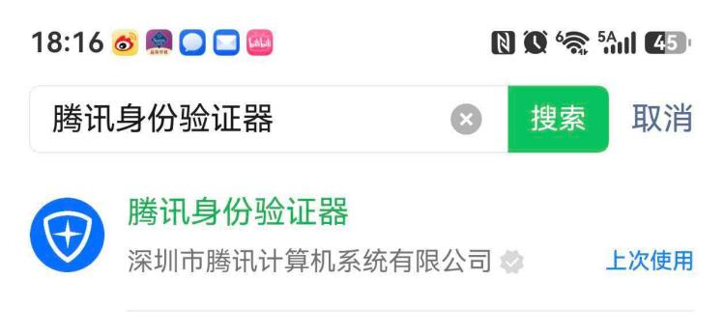

(4) On the mini program home page, choose [Activate via QR Code] and use the camera to scan the QR code on the page in step (2). After successful binding, the authenticator displays a 6-digit dynamic verification code for the account, refreshing automatically every 30 seconds.

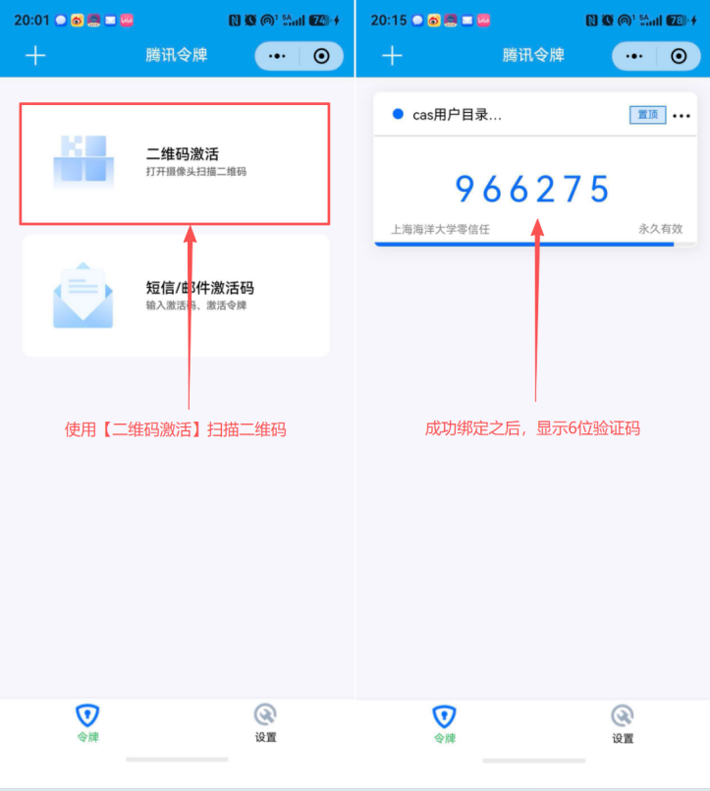

(5) Return to the “Token Authentication” page on the computer, enter the 6-digit dynamic codes one by one in the “TOTP authenticator” input box, and click [OK] to complete authentication and enter the system.

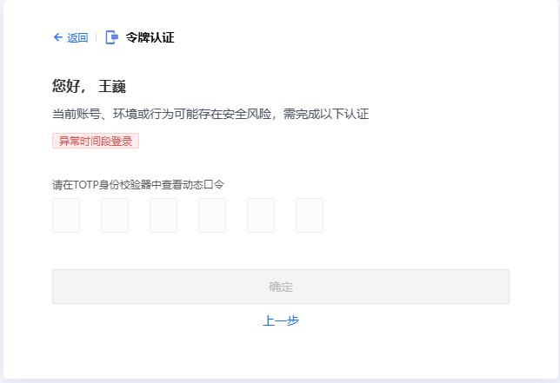

SMS Verification
(1) After binding the token, you can also choose “SMS Authentication” under “Other authentication methods” when logging in again, enter the SMS verification code sent to your bound phone, and click [OK] to complete verification.

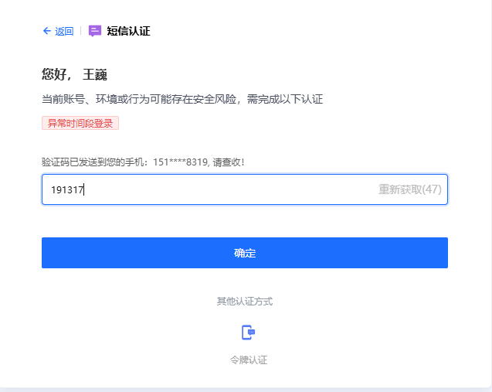

II. Accessing the Zero Trust VPN on a Mobile Phone
(1) Open the Zero Trust VPN client on your phone (the platform supports iOS, Android, HarmonyOS and other mobile versions; search for “aTrust” in the app store to download).
(2) On first use, enter the Zero Trust VPN access address https://vpn4.shou.edu.cn in the server address field and click [Connect]. (After the trial run ends, the access address will change to https://vpn.shou.edu.cn)

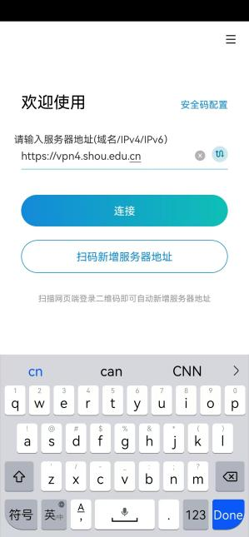

(3) Faculty and students on campus choose the other login method “Unified Identity Authentication” to log in; off-campus third-party users use the default local password authentication.

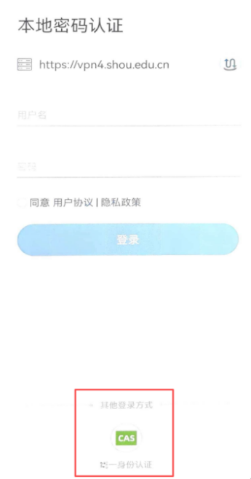
(4) After connecting, you are redirected to the “Unified Authentication Platform” login page. Enter your student/staff ID (account/security phone) and login password (the same as the Online Service Hall account password), and click [Log In].

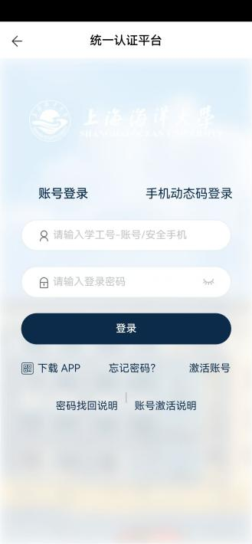

(5) The first login of the account on this terminal requires enhanced authentication. On the “Token Authentication” page, enter the 6-digit dynamic code displayed in the TOTP authenticator and click [OK]. For how to bind the dynamic token, see the “TOT Dynamic Token Binding” section above.

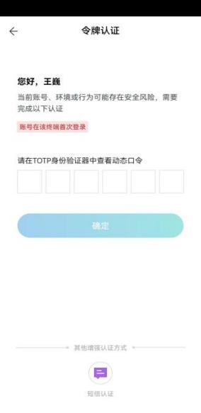

(6) You can also choose “SMS Authentication” under “Other enhanced authentication methods” at the bottom of the page, click [Get Verification Code], enter the SMS verification code sent to your bound phone, and click [OK] to complete verification.

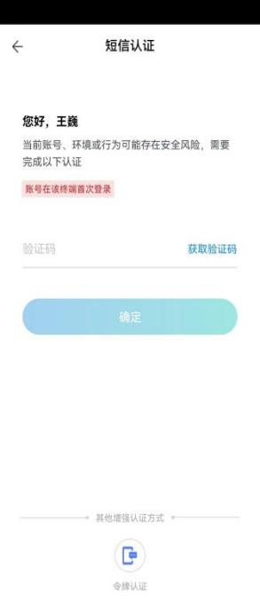

(7) After authentication, the client shows the “Online” status at the top and prompts “Tunnel access enabled”. You can then access shared resources (such as the “Online Service Hall”) and other campus applications in the “Application Center”.

